[](http://www.liverpoolcityregion-ca.gov.uk/)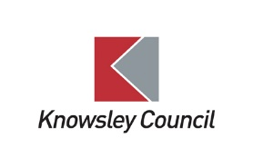

Liverpool City Region Adult Education Budget

**Knowsley FACE**

|  |  |
| --- | --- |
| **Policy:** | Disablity STATEMENT |
| **Date created:** | September 2021 |
| **Date to be renewed:** | September 2022 |

**Disability Statement**

Knowsley FACE is committed to promoting the practice of fairness and to eliminating inequality based on the grounds of age, disability, learning needs, family responsibility, marital status, culture, ethnicity, nationality, religious beliefs, gender, sexual orientation. We aim to recognise and value the contribution made by each individual to our learning environment.

**Reasonable adjustments**

The Service requires staff/learners to provide written evidence of their disability before individual reasonable adjustments can be implemented. Support arrangements can be discussed at a confidential meeting with a senior member of staff.

.

Reasonable adjustments may include:

* Specialist one to one support
* Examination concessions

**Disclosure of a Disability**

The Service provides opportunities for learners to disclose their disabilities should they wish to do so. The service works with learners to identify the most appropriate support to aid them in their learning to achieve a successful outcome.

The Service keeps all student and staff records confidential and will not allow anyone outside the service to access personal information without written consent except when required to do so by law. We will process all personal and sensitive data in accordance with the Data protection Act 1998 and recent GDPR duties.